BOMBS
SOR Clip
Pick up 6x Chillis, 1x Pot Lid, 1x Boko Spear, 3x Mushrooms
TOT Clip
Pick up 1x Traveler’s Bow, 5x Arrows
BLSS to Bombs Shrine

TOWER
Old Man (2,1,1,2)
BLSS to Tower (Blow up Bomb)

Magnesis
<N to Magnesis Shrine
Pick up 1x Ruby

Stasis
BLSS to Apple Tree
Pick up 2x Apples
E to Stasis Shrine

Cryonis
Boulder Launch (Pick up Arrow)
BLSS to Cryonis

Paraglider
BLSS to Temple of Time (Blow up Bomb)

Revali Memory
BLSS to Pick up 2x Razorshrooms
BLSS to Observation Room
Pick up 1x Thunderblade (Throw Spear into Malice Eye)
Pick up Boko Spear again
Pick up 3x Ancient Arrows, 1x Royal Bow, 5x Arrows
WB into Midair to Pillar
BLSS to Fairy Fountain
Pick up 3x Fairy, 7x Mighty Thistle, 2x Silent Princess, 2x Endura Carrot
N. to Tabantha Tower
Pick up 1x Knights Claymore, 1x Royal Claymore
.N Turn Superlaunch to Rito Village
Talk to RitoChief
Talk to Saki

Sha Warvo
Unequip Old Pot Lid
Jump down to Cooking Pot
Pick up 1x Fresh Potlid (Drop Old)
Cook 3x Mighty Thistles + 2x Razorshrooms
Cook 1x Endura Carrot
Cook 1x Endura Carrot
Run to General Store
Drop 2x Chillis, 2x Mighty Thistles
SORT INVENTORY
Generate 5 Offsets (Apple, Chilli, Mushroom, Thistle, Princess)
Pick up Chilli Thistle Pile
Equip Shield, Equip Royal Claymore, Equip Royal Bow
Save
Generate 3 Offsets (Fairy, Thistle, Chilli / Ruby Checkitem)
Eat all Food
Drop Shield and both Bows
Drop and Pick up all Weapons
Unequip Weapon
Reload
Shoot Arrow, without Syncing Game Data
Save/Reload
Sell 9x Ruby
<N Turn to Sha Warvo
Activate Shrine

Noe Rajee
Save
Restart Game
SCW into Noe Rajee

Revali’s Gale
Take Updraft to Teba
Pick up 1x Swallow Bow, 10x Arrows
Flight Range Challenge
Pick up 1x Falcon Bow
Attack Vah Medoh
Equip Royal Bow
Eat Attack Up Food
Windblight Ganon (1 Headshot, Jump on Terminal, 3 Bodyshots / 4 Bodyshots)

Daqo Chisay
Talk to Riot Chief
Pick up 1x Great Eagle Bow
Warp to Keh Namut (Cryonis)
BLSS to Benjamin
Activate Daqo Chisay

Kuh Takkar
E. VR Superlaunch to Kara Kara Bazaar
Buy Gerudo Clothes
VR Superlaunch (Aim at Shrine) to Arrow Shop (Turn off VR)
Buy 30x Fire Arrows, 30x Ice Arrows, 30x Shock Arrows
Talk to Riiju
<N Turn to Enemy Camp
BTB to Gerudo Tower
BTB to Gerudo Canyon
E. Turn to Lizalfos Camp
Pick up 1x Dragonbone Club, 1x Knight’s Shield, 7x Wood
Unfreeze Kuh Takkar
Get E Skew next to Luminous Stone
Activate Shrine

Etsu Korima
Elevator Storage
N to Natural Bridge
ISCW to Etsu Korima
Chu Chu Activation (Ice to Fire)

Ruvo Korbah
E> Turn to Owa Daim (Stasis)
Elevator Storage
Tree Launch Setup
Buffered SCW to Ruvo Korbah

Rohta Chigah
.E Turn to Ja Baij (Bombs)
Kill Decayed Guardian
Elevator Storage
N Square First to SCW Spot (Turn Camera)
Buffered SCW to Rohta Chigah

Yowaka Ita
Warp to Kuh Takkar
Elevator Storage
N to Natural Bridge
ISCW to Yowaka Ita
Watch Memory
Chu Chu Activation (Shock to Fire)
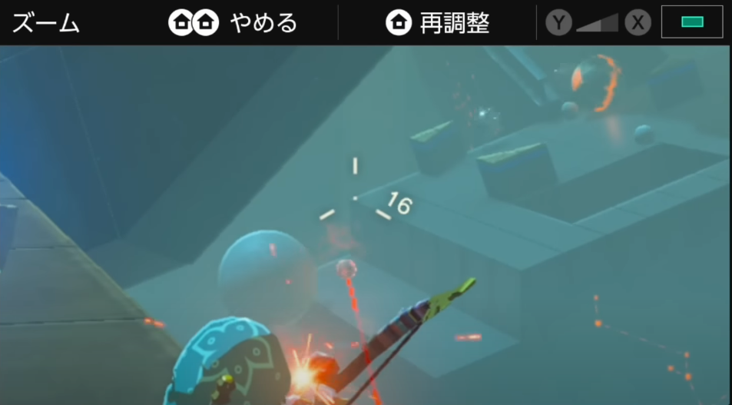

Kihiro Moh
Warp to Kuh Takkar
Elevator Storage
.W towards Hideout
SCW to Kihiro Moh
Campfire Activation

Thunderhelm
Square First towards Hideout
Master Koga Fight (2x GEB Shots, Spin Attack / 2x GEB Shots, Spin Attack / Boulder Strat)
Pick up 1x Thunderhelm

Urbosa’s Fury
Warp to Daqo Chisay
S. to Riiju
Urbosa Memory
E. Superlaunch to Outpost
Attack Vah Naboris (3x Gale)
Eat Attack Up Food
Thunderblight Ganon (Break Shield, 2x GEB Headshots / Magnesis Strat, 2x GEB Shots)

Takama Shiri
W to Sandseal Rental
Buy Sandseal, Activate Takama Shiri

Keive Tala
WB to Skeleton
BLSS to Molduking
Molduking Fight (3x Fury, GEB Shock Arrow Shot)
.S to Shrine Location

Shira Gomar
Warp to Kuh Takkar
Elevator Storage
N to Natural Bridge
ISCW to Shira Gomar
Chu Chu Activation (Neutral to Fire)

Kiah Toza
Warp to Kuh Takkar
Elevator Storage
N to Natural Bridge
ISCW to Kiah Toza
Chu Chu Activation (Fire to Shock)
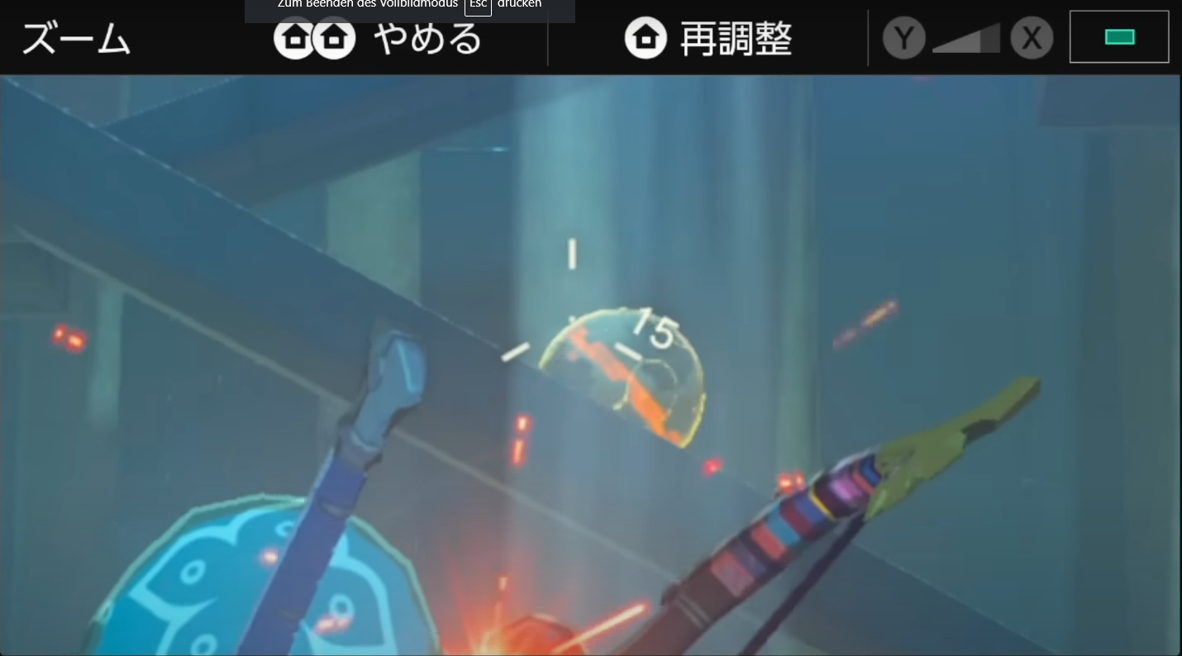

Daruk Memory
S to Talus
BLSS towards Goron City
Midair to Goron City (1x Gale)
Talk to Goron Chief
N. to Cliff
<N Turn to Yunobo
<S Turn to Goron Chief

Daruk’s Protection
.S to Cliff
E Superlaunch + Midair to Yunobo
Kill Moblins (Ancient Arrow)
Yunobo Escort
Vah Rudania (1x Gale)
Fireblight Ganon (3x GEB Headshots / Bomb Strat, 1x GEB Headshot, 2x GEB Headshots)

Mipha Memory
BLSS to Zoras Domain
Fish Drama (Equip Zora Armor)

Mipha’s Grace
E + Midair to Sidon
Attack Vah Ruta
Eat Attack Up Food
Waterblight Ganon (4x GEB Headshots / 1x GEB Headshot, 2x GEB Bodyshots, 2x GEB Headshots)

Dagah Keek
N towards Trident
Pick up 1x Ceremonial Trident
W + S to Pedestal
Activate Dagah Keek
Square First to Shrine

Sato Koda
Elevator Storage
N Midair to Cliff (1x Gale)
N towards Shrine
SCW to Sato Koda
Campfire Activation

Mah Eliya
Kill All Guardians (Anicent Arrows)
Activate Sato Koda
Elevator Storage
E. Turn Superlaunch towards Shrine
SCW to Mah Eliya
Lotus Seed Activation

Kee Dafunia
BLSS to Light Ring
Activate Kee Dafunia

Grace +
Warp to Vah Ruta
Eat Attack Up Food
S towards Vah Ruta
Waterblight Ganon Refight (Flurry Rush, 3/2 Attacks, LVL 2 CA, 1x Fury / 3x HS, 2x Fury)

Sharo Lun
Warp to Sato Koda
Kill Moblin
Elevator Storage
BLSS towards Death Mountain
N to SCW Spot
SCW to Sharo Lun
Amiibo Activation
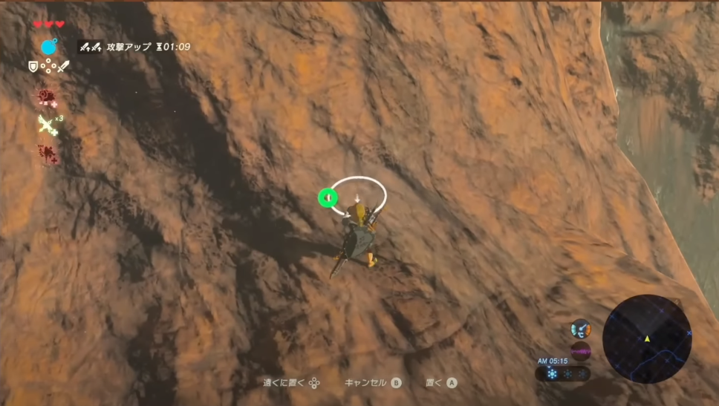

Rino Honika
.W Turn Superlaunch to Light Ring
W Mid Air to Shrine Location
Activate Rino Honika

Kamia Omuna
Elevator Storage
N + N to Canon
BLSS towards Shrine Location
SCW to Kamia Omuna
Ore Activation

Protection +
Warp to Vah Rudania
Eat Attack Up Food
Fireblight Ganon Refight (2x Bombs, 2 Hits, Spin / Bomb Strat, 2 Hits, Spin)

Gale +
Warp to Vah Medoh
Windblight Ganon Refight

Fury +
Warp to Vah Naboris
Thunderblight Ganon Refight (Break Shield, Spin, 2 Hits / Magnesis Strat, Break Shield, Spin)

Motocycle
BLSS to SOR
Start Final Trial
Final Dungeon Skip
Eat Attack Up Food
Monk Maz Koshia (Spin / 2x Fury + GEB Headshots / 1x Gale, 2x GEB Headshots, Big Spin)

Hyrule Castle
BLSS to Hyrule Castle
N to Sanctum
Eat Attack Up Food
Calamity Skip (Swing Righthop, Swing Backflip)
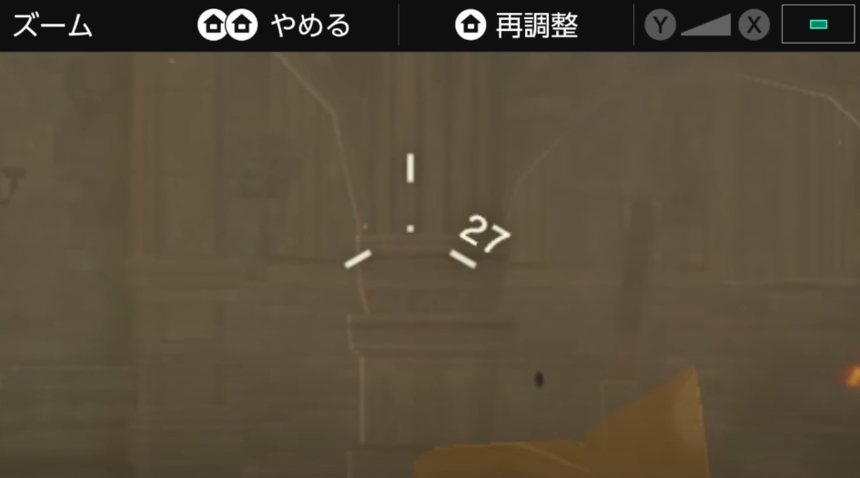
Dark Beast (Motorcycle Strats)
GG

